Creating a Sun-Path Diagram (aka an Altitude-Azimuth Graph) Name: _______________________________
The path that the sun takes across the sky changes throughout the year. Though it is said to rise in the east and set in the west, it only rises exactly east on 2 days of the year: the two equinoxes. On every other day it rises either south of east or north of east. The maximum altitude that the sun reaches also changes throughout the year.
In this activity you will draw a Sun-Path diagram (aka an altitude-azimuth) to represent the path of the sun on three different days of the year: the December solstice, the March equinox, and the June solstice.
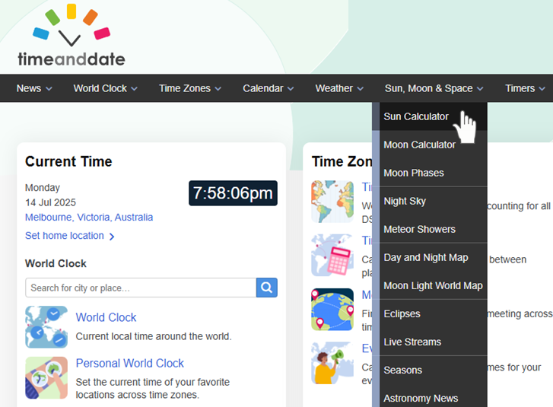
Step 1: Visit the https://www.timeanddate.com/ website, hover over the Sun, Moon & Space tab and then click Sun Calculator.
Step 2: Search for your city. (Your teacher might ask every student in the class to do a different city so that the sun paths can be compared.)
Step 3: If you scroll down, you can navigate to whatever date you wish. Below, you can see that November 2025 – Sun in Melbourne has been selected and the November 2 tab has been clicked. By clicking and holding the little image of the Sun, you can drag it back and forth. The data on the right will tell you the time, the altitude, and the heading (which is actually the azimuth).
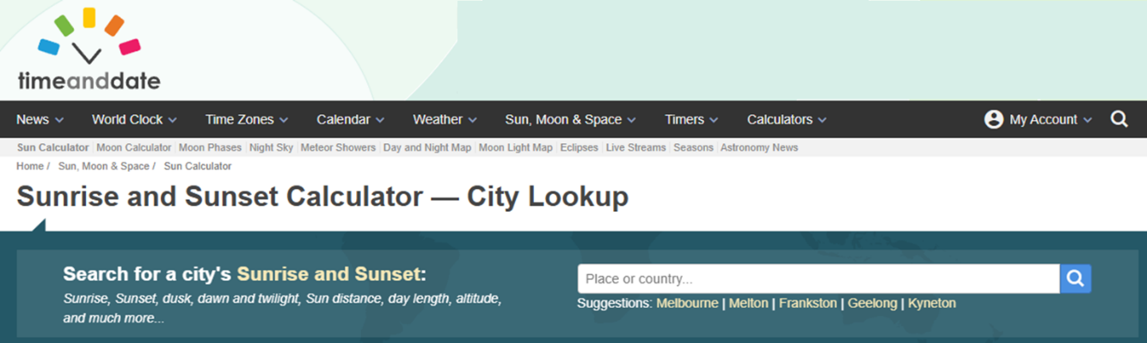
Step 4: Fill in the tables below and then plot the data onto the azimuth-altitude graph. Connect the dots with a smooth line.

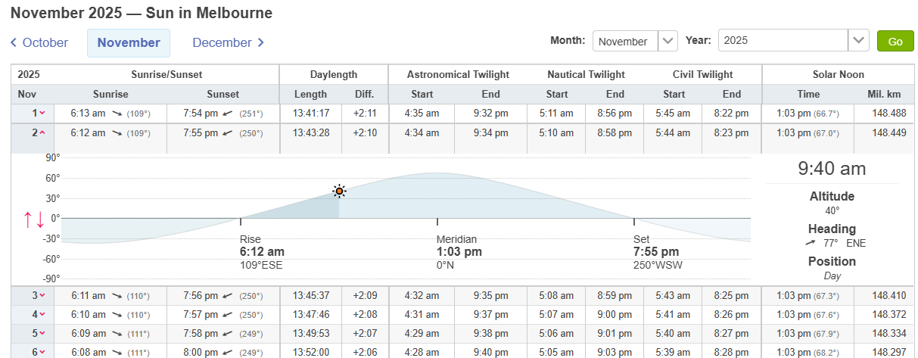

City: _________________________ Latitude: ___________
Date: December Solstice (December 21)
Time | Azimuth (degrees) | Altitude (degrees)
Sunrise _____________________ |  | 0°
7 am
9 am
11 am
Solar Noon (Meridian) __________ | (0° or 180°)
3 pm
5 pm
7 pm
Sunset ____________________ |  | 0°
Please note: some of the times in the tables below may not be applicable, depending on the length of daytime. The timeanddate.com tables don’t always allow you to get an exact time. If you can’t get, for example, exactly 3 pm, just use 3:01 pm.
Write in the times for sunrise, solar noon, and sunset.
The altitude at solar noon is the highest altitude that the sun reaches on any given day. At solar noon, the sun is either directly north of you or directly south of you, depending on where you are and so the azimuth angle will be either 0° or 180°. (An azimuth of 360° is the same as an azimuth of 0°.)
However, if you are in the tropics, the Sun may well pass directly overhead at solar noon and so it will be neither north or south of you!

(The data for the March equinox and the September equinox are very similar.)
City: _________________________ Latitude: ___________
Date: March Equinox (March 21)
Time | Azimuth (degrees) | Altitude (degrees)
Sunrise _____________________ |  | 0°
7 am
9 am
11 am
Solar Noon (Meridian) __________
3 pm
5 pm
7 pm
Sunset ____________________ |  | 0°

City: _________________________ Latitude: ___________
Date: June Solstice (June 21)
Time | Azimuth (degrees) | Altitude (degrees)
Sunrise _____________________ |  | 0°
7 am
9 am
11 am
Solar Noon (Meridian) __________
3 pm
5 pm
7 pm
Sunset ____________________ |  | 0°
There will be three lines on your finished Sun-path diagram.
Sun-Path Diagram. Name: ________________________________

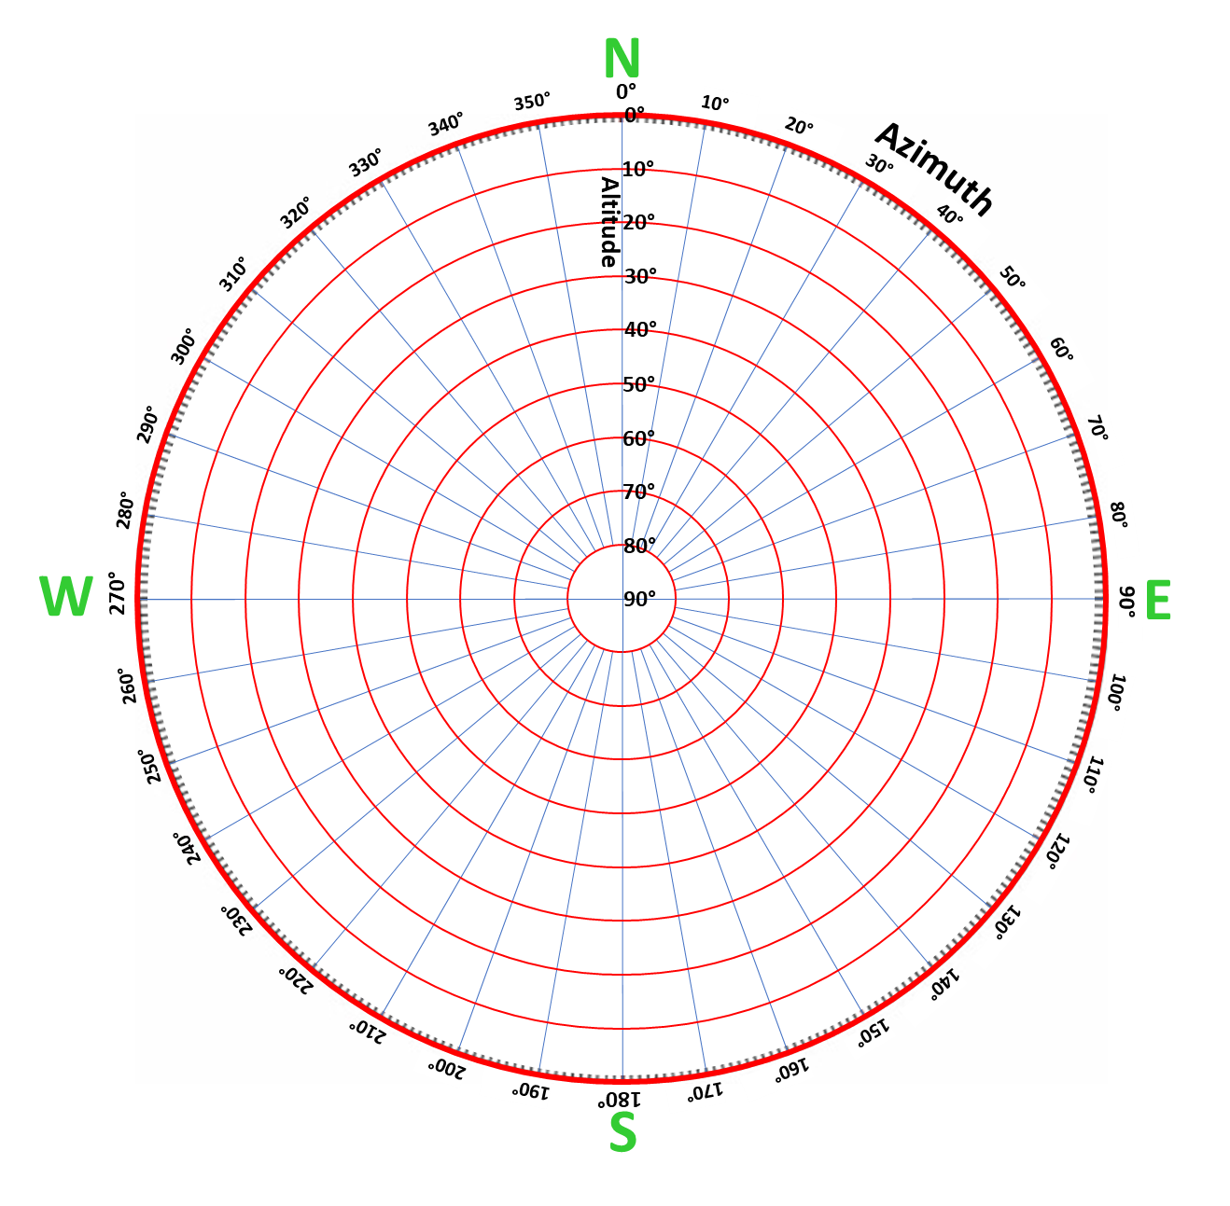
City (or town): ___________________________________ Latitude: _______________________

Mark in the location of
your city or town.

